Academic Year: 2024-25 Semester: V Class / Branch: TE IT
Subject: DevOPs Lab (DL)
Subject Lab In-charge: Prof. Sujata Oak
EXPERIMENT NO.12
Aim: Deploy a website code on the node by provisioning mysql server and database using ansible playbook.
Theory: MySQL Database is a client/server system that consists of a multithreaded SQL server that supports different back ends, several different client programs and libraries, administrative tools, and a wide range of application-programming interfaces (APIs).
Primary Terminologies
- MySQL: For the storage and management of structured data, a lot of people use MySQL, an open-source relational database management system (RDBMS). It offers components, for instance, SQL support, data security, versatility, and execution.
- Ansible is a configuration management tool. it is a suit of software tools that enables infrastructure as code.it is an open source and suit includes software provisioning, configuration management and application deployment functionality. There is no need to install run time, as it is a stand-alone tool.
- Ansible Playbooks- playbooks are the basis for really a simple configuration management and multi-machine deployment system. Ansible playbooks are YAML documents containing a set of instructions for Ansible to execute on remote hosts. Playbooks automate tasks like software installation, service configuration, and file management by defining the desired state of systems.
- Modules for Ansible- Ansible modules are little projects that perform tasks on remote hosts. For common tasks like package management, file manipulation, and service control, Ansible has a lot of built-in modules. The Ansible engine runs modules on the target hosts and sends back the results to the control node.

STEP1:
Ansible-master:
root@ip-172-31-18-177:~/ansible-lab/ansible-codes# nano mysqlmodule.yml
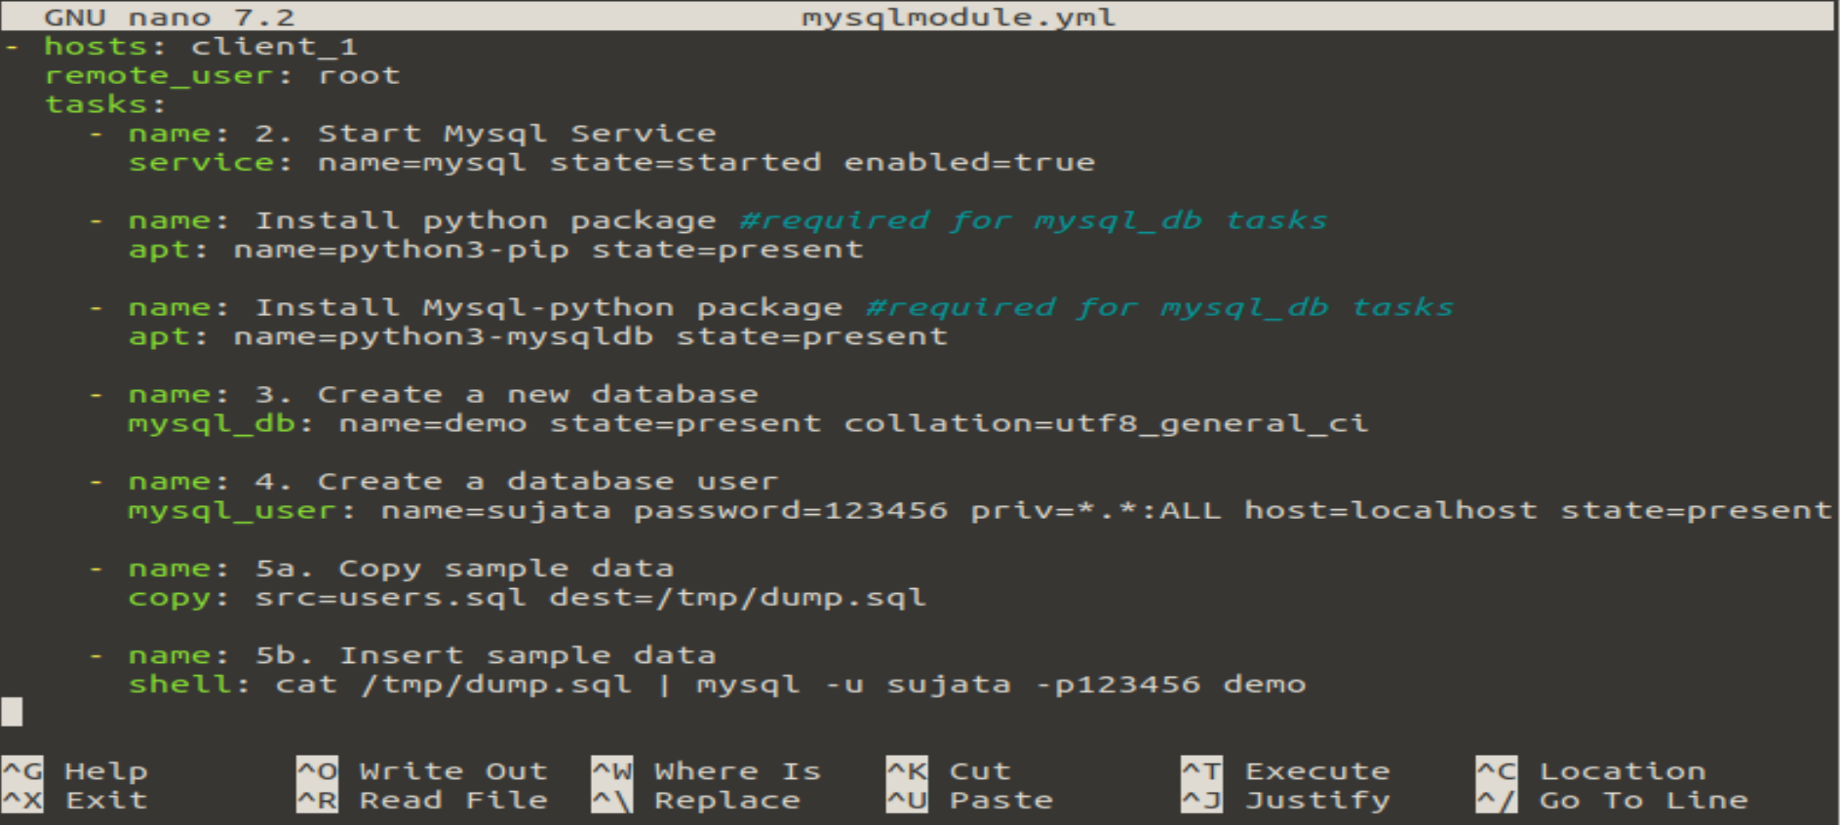
root@ip-172-31-18-177:~/ansible-lab/ansible-codes# cat users.sql

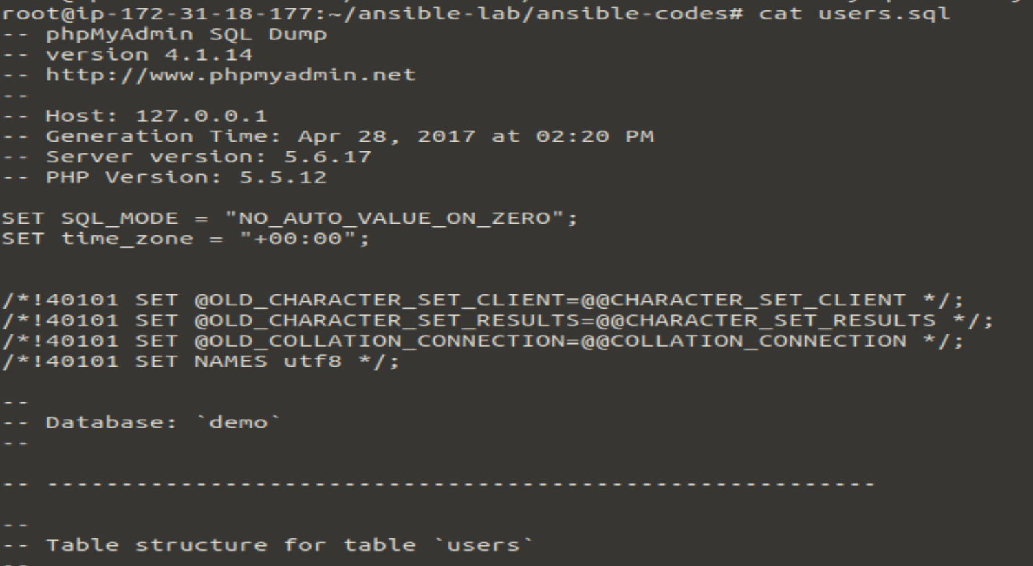
STEP2:
root@ip-172-31-18-177:~/ansible-lab/ansible-codes# ansible-playbook mysqlmodule.yml
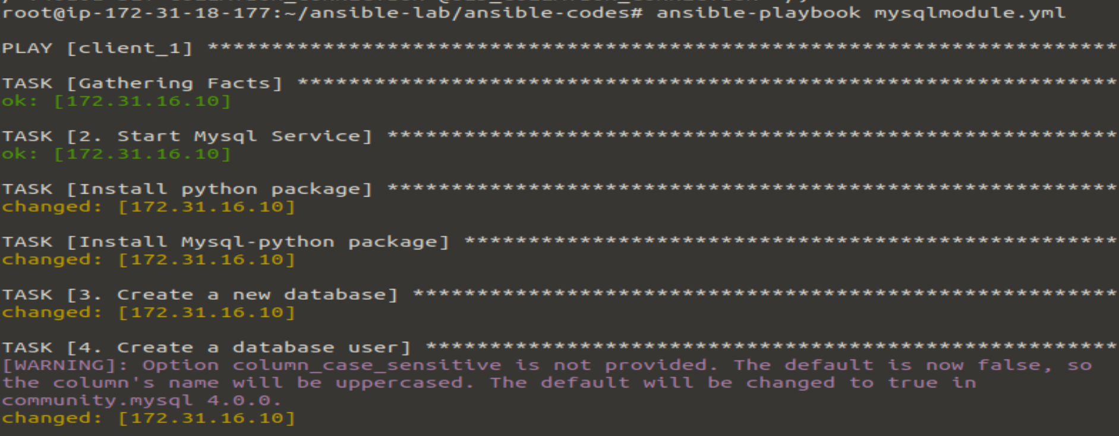
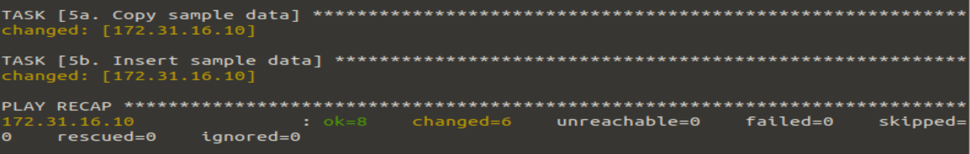
STEP3: ansible-slave
root@ip-172-31-16-10:~# mysql -u sujata -p123456
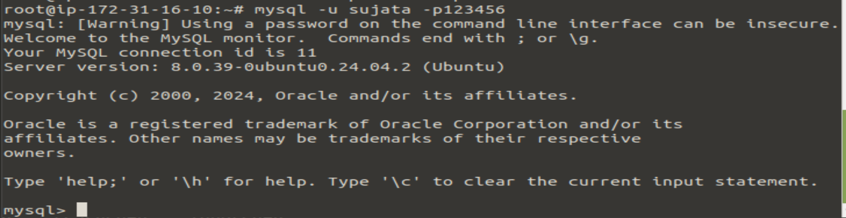
mysql> show databases;
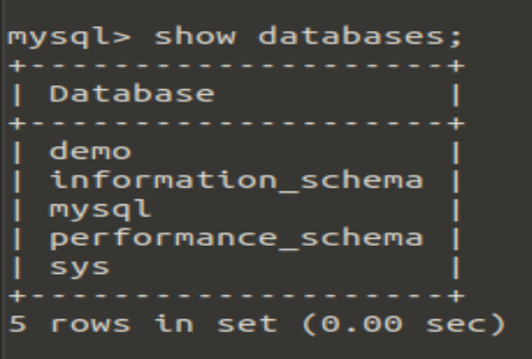
mysql> use mysql;
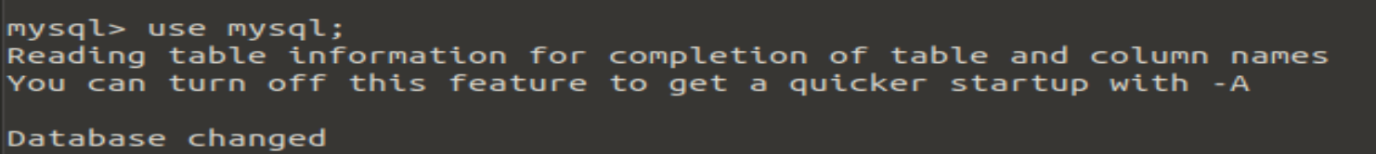
mysql> show tables;
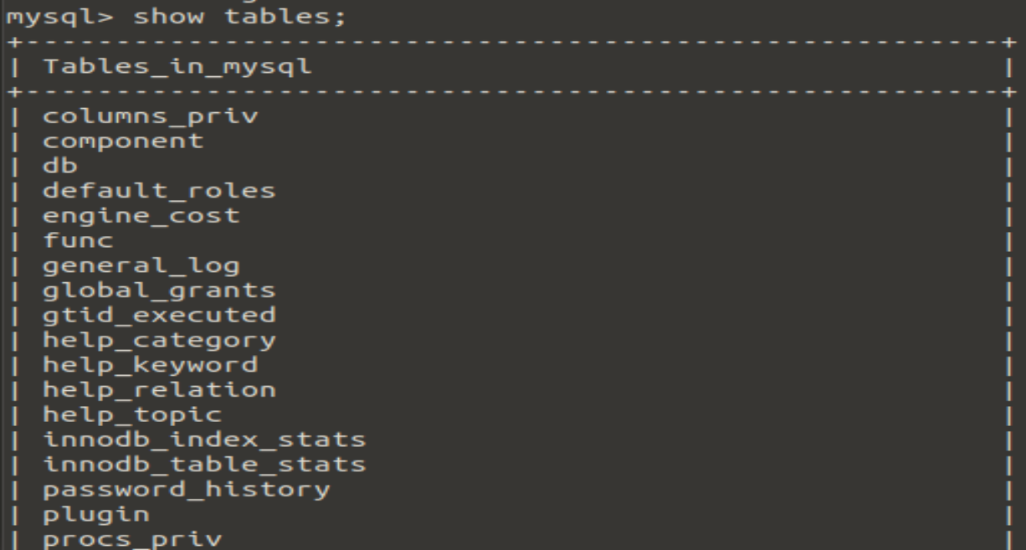
mysql> select * from db;
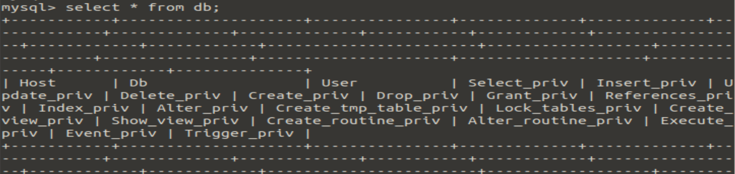
mysql> exit
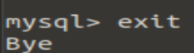
STEP4: ansible-master
root@ip-172-31-18-177:~/ansible-lab/ansible-codes# nano deploywebsite.yml

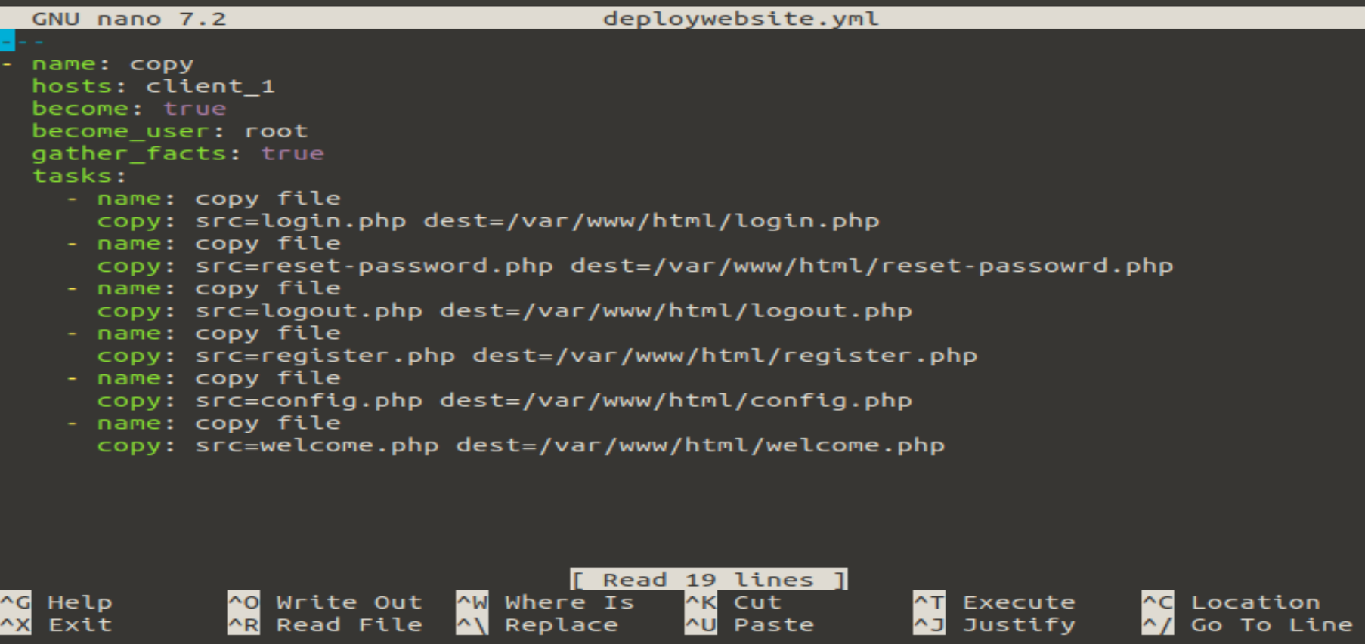
root@ip-172-31-18-177:~/ansible-lab/ansible-codes# ansible-playbook deploywebsite.yml
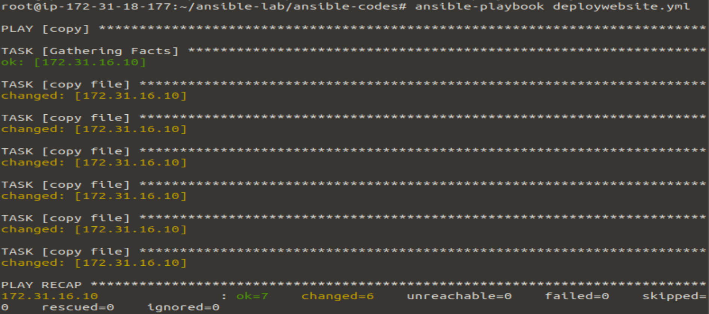
Ansible-slave:
root@ip-172-31-16-10:~# cd /var/www/html
root@ip-172-31-16-10:/var/www/html# ls
config.php login.php register.php welcome.php
index.html logout.php reset-passowrd.php

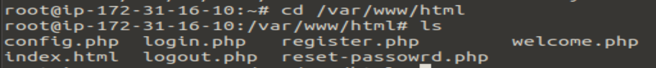
STEP5: Goto Browser: ansible-slave machine IP address/login.php
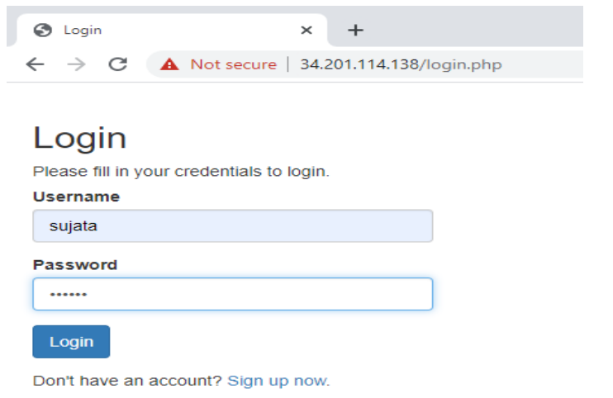
IP address/welcome.php
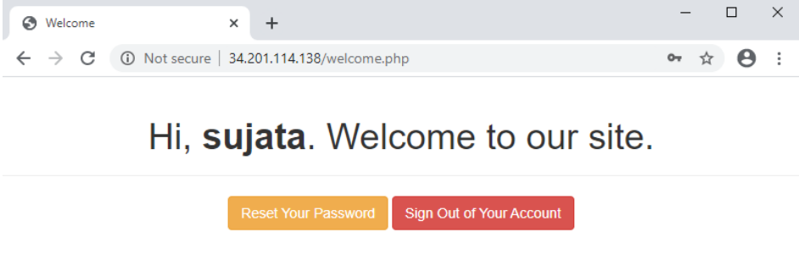
IP address/reset-password.php

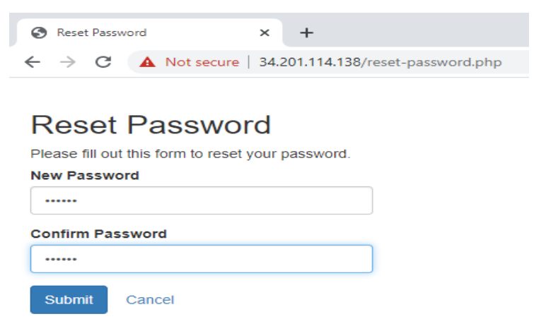
Conclusion: In the experiment, we successfully deploy a website code on the node by provisioning mysql server and database using ansible playbook.

